KPC PUBLIC SCHOOL KHARGHAR
Assessment – V (2022 - 2023)
GRADE : VI MARKS : 50 SUBJECT: MATHS TIME: 2 HRS
Q.1. Choose the correct option (6 M)
1.A Decagon has how many sides?
(a) 8 (b) 9 (c) 10 (d) 7
2.The measure of a reflex angle is
(a) 180° (b) < 180° (c) > 180° (d) < 90°
3.Twelve point one = ______
(a) 12.1 (b) 12.01 (c) 1.21 (d) 0.121
4.Convert 90 minutes into hours.
(a) 2 hours and 17 min (b) 2 hours
(c) 1 hour and 3 min (d) 1 hour and 30 min
5.Out of 30 students in a class, 20 like cricket and 10 like Hockey. The ratio of the number of students liking Hockey to the total number of students is
(a) 3 : 1 (b) 1 : 3 (c) 2 : 3 (d) 1 : 2
6. Choose a value of ‘a’ that satisfies the equation 6a = -30.
(a) 5 (b) 30 (c) -5 (d) 10
Q.2. Solve the following (8 M)
1. Draw an angle of 345° with base 8.2 cm and name the angle.
2. Find the value of
2x - 2 = x + 20
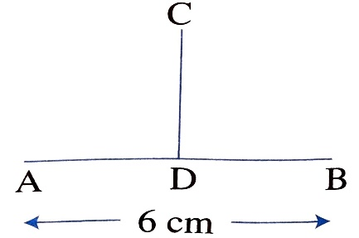
3. If line segments AB is a perpendicular bisector to line segment CD, then what is the length of line segments AD and DB?

4. Find the perimeter of the following figure
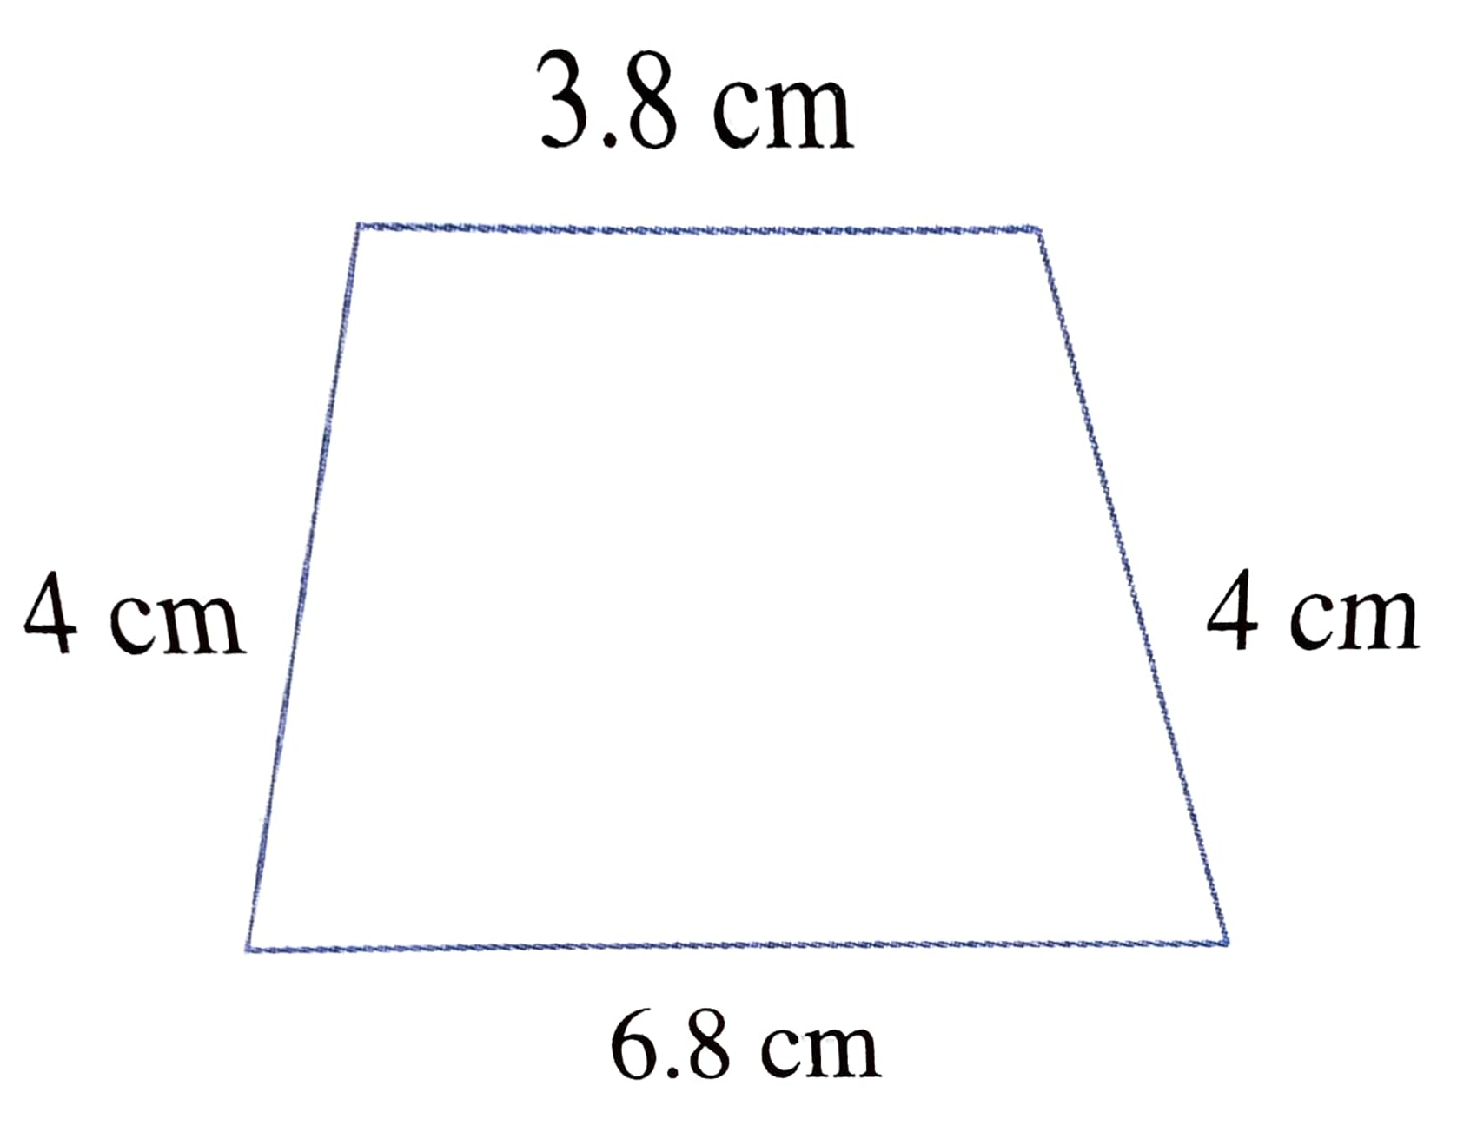
Q.3. Solve the following (9 M)
1. Draw a circle of radius 3 cm and mark points A. B and C such that:
a. A is on the circle. b. B is in the exterior of the circle. c. C is in the interior of the circle
2. Aaron scored 452.65 marks out of 600 in the final examination. How many marks did he lose?
3. A man earns Rs 981 in 9 days. How much will he earn in the month of February in a leap year?
Q.4. Solve the following (Solve any 3) (12 M)
1. An iron rod is cut into three parts in the ratio 3 : 4 : 5. If the total length of the rod is 888 m. find out the length of each part.
2. Bisect a line segment of length 7cm. Write down the steps of construction.
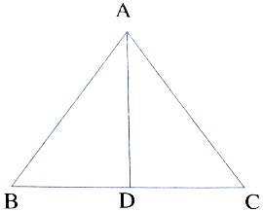
3. Look at the figure and name the following:
a. Identify three triangles in the figure.
b. Write the names of seven angles.
c. Write the names of six-line segments.
d. Which two triangles have ∠C as common.

4.Draw and classify the triangles based on length and angles respectively
a. 6 cm, 6 cm, 6cm. b. 30°, 60°, 90°

Q.5. SOLVE THE FOLLOWING (Solve any 3) (15 M)
1. Four angles of an irregular quadrilateral are in the ratio 1:2:4:5. Find the measure of each angle.
(Hint: The sum of the angles of a quadrilateral is 360°.)
2. Draw the following shapes and state how many edges, faces and vertices they have:
a. Triangular pyramid. b. Square - based pyramid
3. A sack was filled with 26.87 kg of sand. Another sack of 12.39 kg of sand was emptied into the first sack What will be the total weight of the first sack? If 19.43 kg of sand is removed from the first sack, how much sand will be left in the sack?
4. Construct an angle of 30° and copy the same to get a new angle.

